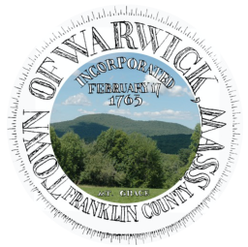
Town Of Warwick | Town of Warwick  12 Athol Road  Warwick, MA 01378 | Phone: 978-544-6315  FAX: 978-544-6499  coordinator@town.warwick.ma.us  www.town.warwick.ma.us | Selectboard:  Brian Snell, Chair  Alan Genovese  Keith Ross

Certificate of Announcement pursuant to 301 CMR 51.07(2)
DCR #P-001128, Town of Warwick

I, Brian Snell, Clerk of the Select Board of the Town of Warwick, Massachusetts, do hereby certify that on August 17, 2026, it was announced at a public meeting of the Board of Selectmen that:

The Department of Conservation and Recreation may acquire an interest in a parcel of land located in Warwick as shown on the attached locus map marked as “Exhibit A” for conservation and/or recreation purposes.

Date:
Brian Snell, Clerk, Warwick Selectboard

