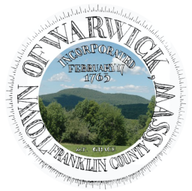  Town Of Warwick | Town of Warwick  12 Athol Road  Warwick, MA 01378 | Phone: 978-544-6315  FAX: 978-544-6499  coordinator@town.warwick.ma.us  www.town.warwick.ma.us | Selectboard:  Alan Genovese, Chair  Keith Ross  Brian Snell

Public Forum

Where: Online & Town Hall (12 Athol Rd, Warwick, MA)

When: September 24, 6pm

What: 6-Town Regionalization and Franklin County Tech Building Project
Vote Informed! Learn more about the two school-related votes on October 6th. Moderated by Lizzie Alwan, Town Coordinator
Notice of potential Warwick Selectboard; School Committee; Highway Commission; Finance Committee; Planning Board meeting within the Public Forum. Notice given in the event a quorum is obtained at the forum so deliberation may occur.
Zoom Link
https://bit.ly/4etfTvx
Meeting ID: 371 759 7885 Passcode: 12
+19292056099,,3717597885#,,,,*12#
Can’t join us? Submit a question ahead of time!
Submit a question HERE or email Lizzie Alwan at coordinator@town.warwick.ma.us

6 PM - Presentation 1: 6-Town Regionalization presented by Greg Snedeker, Vice-Chair, Six Town Regionalization Planning Board

45 minutes for question and answer with:
Panelists
Selectboard Chair: Alan Genovese
Finance Committee Chair: Jill DeLisle
School Committee Chair: Diana Noble
Presenter: Greg Snedeker, Vice-Chair, Six Town Regionalization Planning Board

20 minute break
7:30 PM - Presentation 2: Franklin County Technical School (FCTS) Building Proposal presented by Liz Bouchard, Business Manager, Franklin County Technical School

45 minutes for question and answer with:
Panelists
Selectboard Chair: Alan Genovese
Finance Committee Chair: Jill DeLisle
Warwick FCTS Representative: Todd Weed
Presenter: Liz Bouchard, Business Manager, Franklin County Technical School

Supporting Documents - 6-Town
About This Information: This information is provided to help Warwick voters understand the October 6, 2026 ballot question. It is intended to present the ballot question and available source materials.
- OFFICIAL BALLOT QUESTION:
“Shall the Town accept the provisions of sections sixteen to sixteen I, inclusive, of chapter seventy-one of the General Laws, providing for the establishment of a regional school district, to consist of the towns of Bernardston, Gill, Leyden, Montague, Northfield and Warwick, and to be known as the Great River Regional School District (the “New District”)? The New District would be formed and governed in accordance with an agreement filed by the Six Town Regional Planning Board with the Select Board - either the six-town agreement (the “Six-Town Regional Agreement”) or the five-town agreement (the “Five-Town Regional Agreement”), depending on the results of this vote as described below (copies of both of which are available for inspection at Town Hall and on the website 6towns.org).
If a majority of the voters present and voting in each of the towns of Bernardston, Gill, Leyden, Northfield, Warwick and Montague, vote in the affirmative, the New District shall be established to include all six towns, and the Six-Town Regional Agreement shall thereupon become effective and govern the New District, subject to approval of the Regional Agreement by the commissioner of elementary and secondary education; provided, however, that if a majority of the voters of the Town of Warwick present and voting on this question does not vote in the affirmative, the New District shall instead be established to include only the towns of Bernardston, Gill, Leyden, Northfield and Montague, shall not include the Town of Warwick, and the Five-Town Regional Agreement shall thereupon become effective and govern the New District, subject to approval of the Regional Agreement by the commissioner of elementary and secondary education.
Full operation of the New District, and dissolution of the Gill-Montague Regional School District (the “GMRSD”) and the Pioneer Valley Regional School District (the “PVRSD”), shall be further subject to enactment of special legislation permitting (a) the transfer of the buildings and other assets and liabilities of each of the GMRSD and the PVRSD to the New District on the date the New District becomes fully operational (at the end of the transition period specified in the Regional Agreement); and (b) the dissolution of the GMRSD and the PVRSD on that same date without further action by any public body.”

SUMMARY
You are voting on whether to create a new regional school district called the Great River Regional School District (GRRSD).
The proposed district would combine the schools in these six towns:
- Bernardston
- Gill
- Leyden
- Montague
- Northfield
- Warwick

A YES VOTE
Form a new GRRSD with all six member towns.

A NO VOTE
If Warwick votes no and the other five towns vote yes, a new GRRSD district with five of the six member towns. If any of the five member towns (other than Warwick) vote no, keep the current structure as-is.
- Websites/Reports:
  - 6-Town Website
  - 6-Town Regional Agreement
  - Fiscal Sustainability and Cost Pressure Analysis (From 6-town)
  - Ballot Vote Presentation (From 6-town)

- Videos
  - Warwick School Committee Discussion of Six Town Proposal (Discussion starts at 35 minute mark)

- Warwick Next Steps (from 6-Town Committee)
“The final step in the process of our work is the most important one. The voters in all six towns decide the future of our students’ education and the affordability of the towns. Warwick has taken the first step thanks to many dedicated people by reopening its school for the betterment of its students and the town. It now has an opportunity through the economy of scale with other communities to keep it open.
The present and future financial challenges are undeniable and our taxpayers will decide if we go it alone or unite our efforts to offer quality educational opportunities for ALL our students with greater sustainability and more affordable and predictable assessments. This decision is not just about our elementary students, but the education our secondary students as well.
Next Steps:
In the Fall, Warwick voters will have the opportunity to vote on a proposed Six Town Regional Agreements along with the towns of Bernardston, Gill, Leyden, Montague and Northfield. In addition to this agreement, the voters in the other towns will be voting on a Five Town Agreement (all towns except Warwick).
➢ If one RA passes, upon the approval of the Commissioner of Education, the Selectboards in each town, along with current school committee members from that town, will appoint residents to serve on the Great River Regional School District (GRRSD) Committee for a two-year period.
➢ They will be charged with “setting up the new district” according to DESE regulations and state laws to ensure a smooth transition for students.
➢ The GRRSD will become fully operational on July 1, 2028.
The demographic and financial landscape has changed. One pathway to give our students the educational experience they deserve is PreK to 12 regionalization. Partial regionalization at the secondary level (grades 7-12) is not sustainable, as the full weight of specialized services and transportation for its elementary students will continue to be first fully borne by the town, and then moderately reimbursed by the state.
This is an amazing opportunity to create something special and exciting to serve the next generation of all our students. Warwick has had strong participation in developing the parameters of the proposed GRRSD to avoid the painful experience we endure in the recent past. This in and of itself is noteworthy and a rare opportunity for the Town.
It takes courage and a leap of faith to move from the known to the unknown. We did it before in the 1950s/60s and again when Warwick fully regionalized preK-12 in the early 90’s, for financial and other reasons. Our students and community benefited significantly for many years. Please direct comments, questions, and concerns to 6towns.org.
* Warwick’s future financial sustainability of operating an independent municipal school district will be the focus of the next topic.
Submitted on behalf of the Six-Town Regionalization Planning Board”

Supporting Documents - Franklin County Technical School
About This Information: This information is provided to help Warwick voters understand the October 6, 2026 ballot question. It is intended to present the ballot question and available source materials.
- OFFICIAL BALLOT QUESTION:
Do you approve of the vote of the Regional District School Committee of the Franklin County Regional Vocational Technical School District adopted on June 10, 2026, authorizing the District to borrow a sum not to exceed $236,572,983 to pay the costs of designing, constructing, equipping, and furnishing a new Franklin County Technical School, which vote provides, in relevant part, as follows:
“VOTED: That the Franklin County Regional Vocational Technical School District hereby appropriates the amount of $236,572,983 for the purpose of paying costs of designing, constructing, equipping, and furnishing a new Franklin County Regional Vocational Technical School and related facilities, located at 82 Industrial Boulevard in Turners Falls, Massachusetts, including the payment of all costs incidental or related thereto (the “Project”), which school facility shall have an anticipated useful life as an educational facility for the instruction of school children of at least 50 years, and for which the District may be eligible for a school construction grant from the Massachusetts School Building Authority
(“MSBA”), said amount to be expended at the direction of the School Building Committee. To meet this appropriation, the District is authorized to borrow said amount, under and pursuant to Chapter 71, Section 16(n), of the General Laws and the District Agreement, as amended, or pursuant to any other enabling authority. The District acknowledges that the MSBA’s grant program is a non-entitlement, discretionary program based on need as determined by the MSBA, and any Project costs the District incurs in excess of any grant approved by and received from the MSBA shall be the sole responsibility of the District; provided further that any grant that the District may receive from the MSBA shall not exceed the lesser of (1) sixty-six and twenty-seven hundredths percent (66.27%) of eligible, approved Project costs, as determined by the MSBA, or (2) the total maximum grant amount determined by the MSBA, and that the amount of borrowing authorized pursuant to this vote shall be reduced by any grant amount set forth in the Project Funding Agreement that may be executed between the District and the MSBA.”
SUMMARY
This question asks voters to approve the Franklin County Regional Vocational Technical School District's authorization to borrow up to $236,572,983 to design, construct, equip, and furnish a new Franklin County Technical School in Turners Falls. The project may be eligible for financial assistance from the Massachusetts School Building Authority (MSBA), which could reduce the amount ultimately borrowed.
Unlike the Six-Town regionalization question, this is a district-wide vote. The outcome is determined by a majority of voters across the 19 member towns voting on the question; each town does not have to approve the question separately.

A YES VOTE
A YES vote would approve the Franklin County Regional Vocational Technical School District's authorization to borrow up to $236,572,983 for the proposed new Franklin County Technical School and related facilities, subject to the terms stated in the ballot question.

A NO VOTE
A NO vote would not approve the borrowing authorization described in the ballot question.

- Websites
  - Franklin County Technical School Building Project
  - FCTS Building Project FAQ
  - FCTS Financial Impact

Annual Estimated Tax Increase Calculator for Warwick
Assessed property value | Estimated annual tax increase
200k | $140
400k | $280
600k | $420
800k | $560

Calculated using the FCTS Annual Estimated Tax Increase Calculator

  - MSBA 2026 Statement of Interest FAQ
- Videos
  - FCTS Project Scope and Budget
  - FCTS Existing Facility
  - FCTS How We Got Here
  - FCTS Massachusetts School Building Authority (MSBA) Opportunity
  - FCTS Schematic Design
  - MSBA Statements of Interest
- New Building Proposed (from FCTS’ FCTS Building Project)
Independent reviews by the Massachusetts School Building Authority (MSBA) have found that the current school no longer meets the educational needs of our students now or in the future.

The reality is our current building has reached the end of its life as a viable educational
Institution. The school has outdated and deteriorating systems and infrastructure, overcrowding in classrooms, halls and cafeteria, poor energy efficiency, lack of natural light, inadequate fire protection, and spaces (assembly hall, music room) converted to classrooms to address overcrowding.

As a result of those findings, the MSBA has accepted Franklin County Tech into its highly competitive school building program. In order to go forward, funding for the project would need to be approved by our 19 district communities.

FCTS is proposing to build a new 211,075 square foot, H-shaped school adjacent to its current location at 82 Industrial Boulevard, Turners Falls. If the project is approved by member communities, the school is projected to be open by for the beginning of the 2030-2031 school year. The communities vote on the proposal in October.

If a new school is approved and constructed, FCTS would qualify for up to 60% of MSBA reimbursement funding, with the actual figure likely coming in at around 50%. At a projected cost of $236 million for a new school, a 50% state reimbursement would cut the cost by close to $125 million.

If the project is not approved the school would lose reimbursement funding from the MSBA, but repairs, replacements and improvements would still need to be made costing approximately $75 million. Even then, the serious underlying problems would still not be resolved and more money would need to be spent in coming years just to keep the aging and deteriorating school operational.

The cost of any repairs, replacements and improvements now or in the future would be paid by the taxpayers in our 19 district communities.
Our goal is to provide our students with the highest quality academic and vocational educational experience possible in a modern, sustainable, safe and accessible facility. A new school would be a fresh, up-to-date facility that would meet the needs of Franklin County Tech students for decades to come.

A new school would be a community asset and include access to the Apprentice Restaurant, Cosmetology salon, adult education classes, events in the auditorium, athletic competitions, community events, and various services. Franklin County Tech belongs to all of the citizens of Franklin County and we would very much appreciate your support for this project. Thank you.

- Warwick’s Initial Debt Service Projection from FCTS Financial Impact 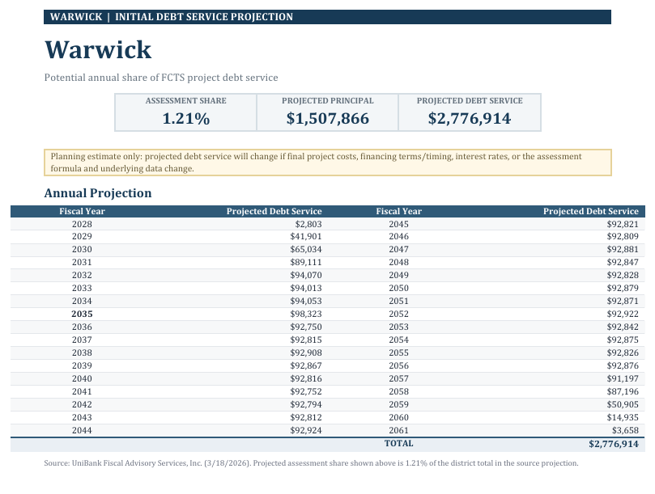

- Policy Statement regarding the impact on MSBA funding if a City, Town or
Regional School District fails to vote to appropriate funding for the proposed
project as defined in the Project Scope and Budget Agreement, within the deadlines established by the MSBA
From Massachusetts School Building Authority MSBA Failed Local Vote Policy (PDF)

The Project Scope and Budget Agreement, as approved by the MSBA’s Board of
Directors, defines the scope, cost and schedule of the agreed upon proposed project, and any variances from this Agreement require the written approval of the MSBA and may require an additional Board vote. Pursuant to the MSBA’s regulations, a city, town or regional school district that has been approved by the Board for a proposed project has 120 days from the date of the Board’s approval to obtain and certify local approval of an appropriation to fully fund the proposed project and all other local votes or approvals
showing acceptance of the cost, site, type, scope and timeline for the proposed project.

The MSBA appreciates the challenges that school districts face, but the MSBA’s
regulations specifically include this 120-day deadline for a local appropriation to ensure
that the MSBA’s capital program funds are targeted toward projects and school districts
that are ready and able to make the financial commitment and move forward in a timely
manner. Given the overwhelming capital needs of school districts across the
Commonwealth and the MSBA’s limited capital program funds, the MSBA cannot
indefinitely tie up funds allocated for a project that lacks local support.

In the event that a school district fails to approve funding for a proposed project within
the 120-day deadline, by no later than 10 business days following the failed vote, the
school district must submit to the MSBA a plan that: (1) presents the vote results, (2)
explains the school district’s understanding of the reason(s) for the failed vote, and (3)
sets forth the school district’s plan to remedy the failed vote and a suggested timeline for
such a remedy. The MSBA will review the plan and determine whether it can continue to
set aside MSBA funds for the proposed project. However, a failed local vote likely will
result in the school district being required to submit a new Statement of Interest to the
MSBA and await an invitation from the MSBA to enter the Eligibility Period phase of the
MSBA’s process.

Policy Statement regarding the impact on MSBA funding if a City, Town or
Regional School District fails to vote to appropriate funding for a feasibility study

In the event that a school district fails to approve funding for a feasibility study, by no
later than 10 business days following the failed vote, the school district must submit to
the MSBA a plan that: (1) presents the vote results, (2) explains the school district’s
understanding of the reason(s) for the failed vote, and (3) sets forth the school district’s
plan to remedy the failed vote and a suggested timeline for such a remedy. The MSBA
will review the plan and determine whether it can continue to set aside MSBA funds for
the feasibility study. However, a failed local vote likely will result in the school district
being required to submit a new Statement of Interest to the MSBA and await an invitation from the MSBA to enter the Eligibility Period phase of the MSBA’s process.
