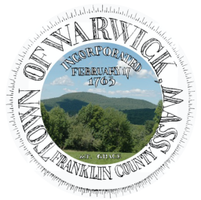  Town Of Warwick | Town of Warwick  12 Athol Road  Warwick, MA 01378 | Phone: 978-544-6315  FAX: 978-544-6499  coordinator@town.warwick.ma.us  www.town.warwick.ma.us | Selectboard:  Alan Genovese, Chair  Keith Ross  Brian Snell

Notice to Abutters: Public Hearing
Town of Warwick MA Select Board

The Warwick Select Board will hold a hybrid public hearing (in person and online) on Monday, August 31, 2026, at 6:30 PM at the Warwick Community School Children’s Library, 41 Winchester Rd Warwick 01378, and via Zoom.

Remote option:
https://bit.l
y/4etfTvx
Meeting ID: 371 759 7885 Passcode: 12
+19292056099,,3717597885#,,,,*12#
This meeting is noticed under legacy OML so requires a quorum of the board in the room and if the remote aspect fails the meeting may continue.
The purpose of this hearing is to consider a request from Massachusetts Electric Company d/b/a National Grid and Verizon New England, Inc to locate poles, wires, and fixtures, including the necessary sustaining and protecting fixtures, along and across the following public way:
South Holden Rd - National Grid to relocate 1 JO Pole on South Holden Rd beginning at a point approximately 325 feet northeast of the centerline of the intersection Of Wendell Rd and South Holden Rd and continuing approximately 26 feet in a southwest direction. National Grid to relocate Pole 2 and its anchor & guy approximately 26 feet southwest of existing pole 2 location so builder can safely construct new home at 20 Holden Rd. Existing pole and anchor location will be close to new home.
The application and related materials are available for public inspection at the Town Coordinator's Office during regular business hours.
For more information, please contact the Town Coordinator at (413)824-5063 in the Selectboard Office or by email at coordinator@town.warwick.ma.us.
This notice is being provided to abutters and interested parties in accordance with applicable requirements.

