Town Of Warwick  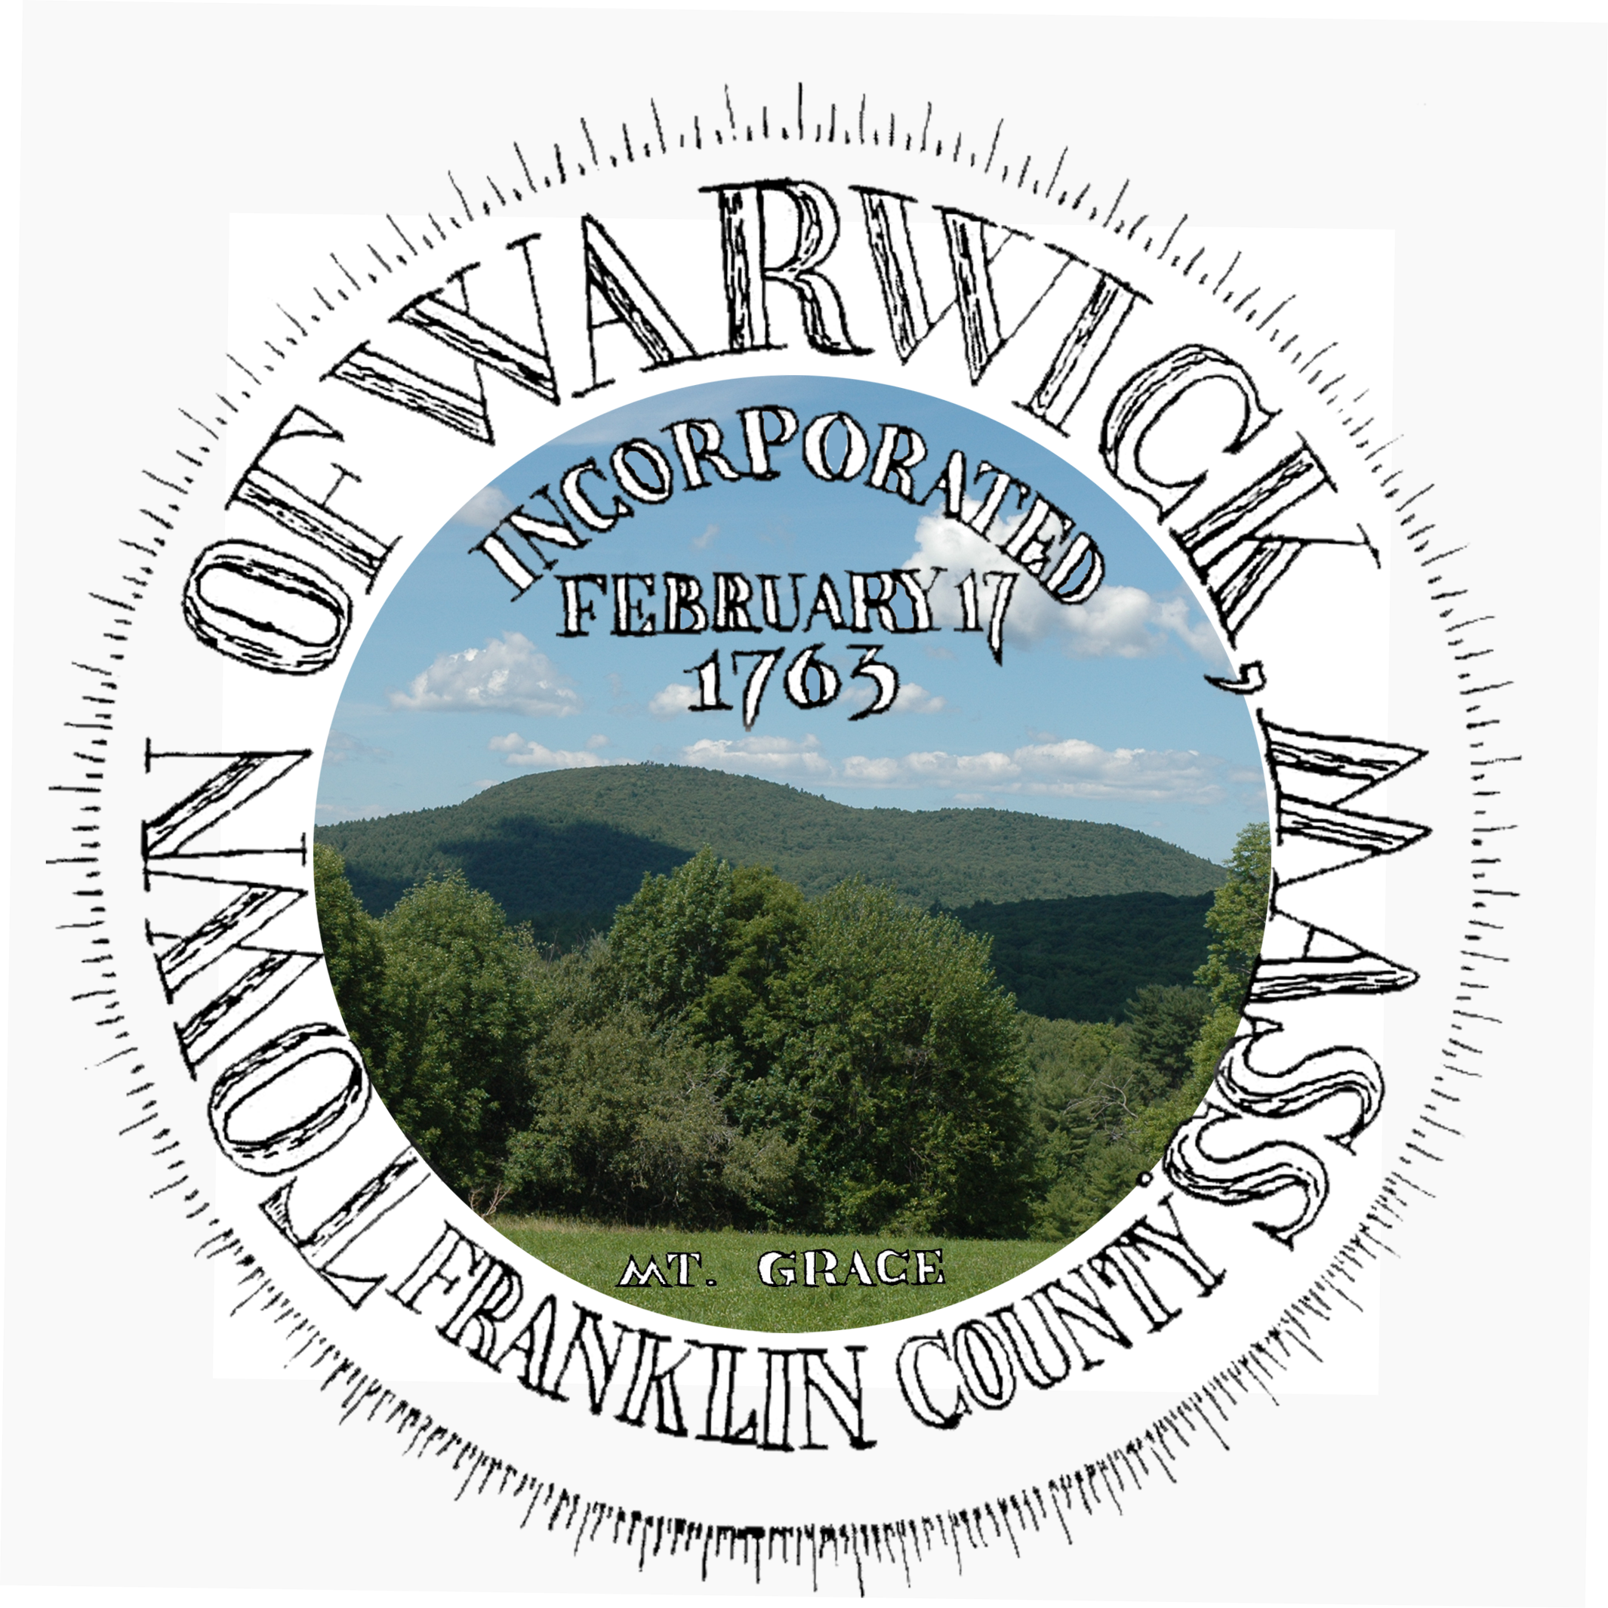 | Town of Warwick  12 Athol Road  Warwick, MA 01378 | Phone: 978-544-6315  FAX: 978-544-6499  coordinator@town.warwick.ma.us  www.town.warwick.ma.us | Selectboard:  Alan Genovese, chair  Keith Ross  Brian Snell

Select board meeting notes
October 10, 2023

Met at the school library to discuss related items under unanticipated business.

1. Transfer Station fence line damage / repairs. Todd & Mike met with the board to discuss the best approach on fence repairs to the damaged section to the south of the main gate. A tree had fallen on the fence causing structural damage which was explained to the board. We had asked about funds to make repairs seeing the Transfer Station does not have a maintenance budget. ARPA funds were suggested, the board said if the commission could get two estimates and bring it back to a future meeting they would deliberate and discuss appropriation from ARPA for the repairs. Todd said he would bring their findings back to the commission meeting on Wednesday, 10/11 for discussion. Chair Alan Genovese asked that we reserve an agenda item for their next meeting to discuss.

2. Security cameras for the yard, gate and attendant’s shed. The board was brought up to speed on trespassing issues and past break in issues at the attendant’s shed. After lengthy discussion commission members came to a consensus to seek funding for installing cameras. The board took it under consideration and town coordinator David Young said he is finishing up a grant application for cameras at the school. He noted that he could add the transfer station into the grant along with all town owned buildings. The board came to a consensus agreeing to allow David to add the additional locations to the grant.

3. Road & Entrance repairs. Highway Commissioner Kevin Alden and Highway Supervisor Larry Delaney were at the SB meeting. Discussion was brought up on repairing the road. Both the SB and Commissioner Alden agreed that the highway department could make the necessary repairs with the loader by adding and grading it with gravel. Larry was surprised that everyone thought the road was in bad shape. Dawn Magi was present and she had raised concern. Larry will also remove the pile of dirt inside the gate below the damaged area of the fence so access can be gained from both sides.

4. Attendant Gerry Whitney’s medical condition. Due to the length of time Gerry has been away the SB decided to ask for a doctor’s note regarding his fitness to return to work. Alan Genovese was concerned about his ability to lift and move things around and ability to perform job tasks that may result in physical duress if he is not 100%.

Taken by Todd Dexter, Commission Member

